**AWS GLUE**

* Managed extract, transform, and load (ETL) service
* Useful to prepare and transform data for analytics
* Fully **serverless** service

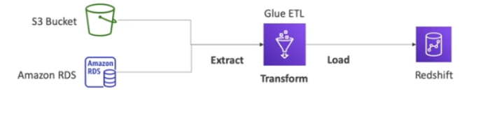

* Glue data catalogue: catalogue of datasets
* Can be used by Athena, EMR, Redshift